**DIGITAL SYSTEMS**

**PRACTICUM 10**



**By:**

**ARIA WIDIYO NOVIYANTO**

**NIM: L200183043**

**INFORMATION TECHNOLOGY**

**FACULTY OF COMMUNICATION AND INFORMATICS**

**UNIVERSITY OF MUHAMMADIYAH SURAKARTA**

**Experiment 1**

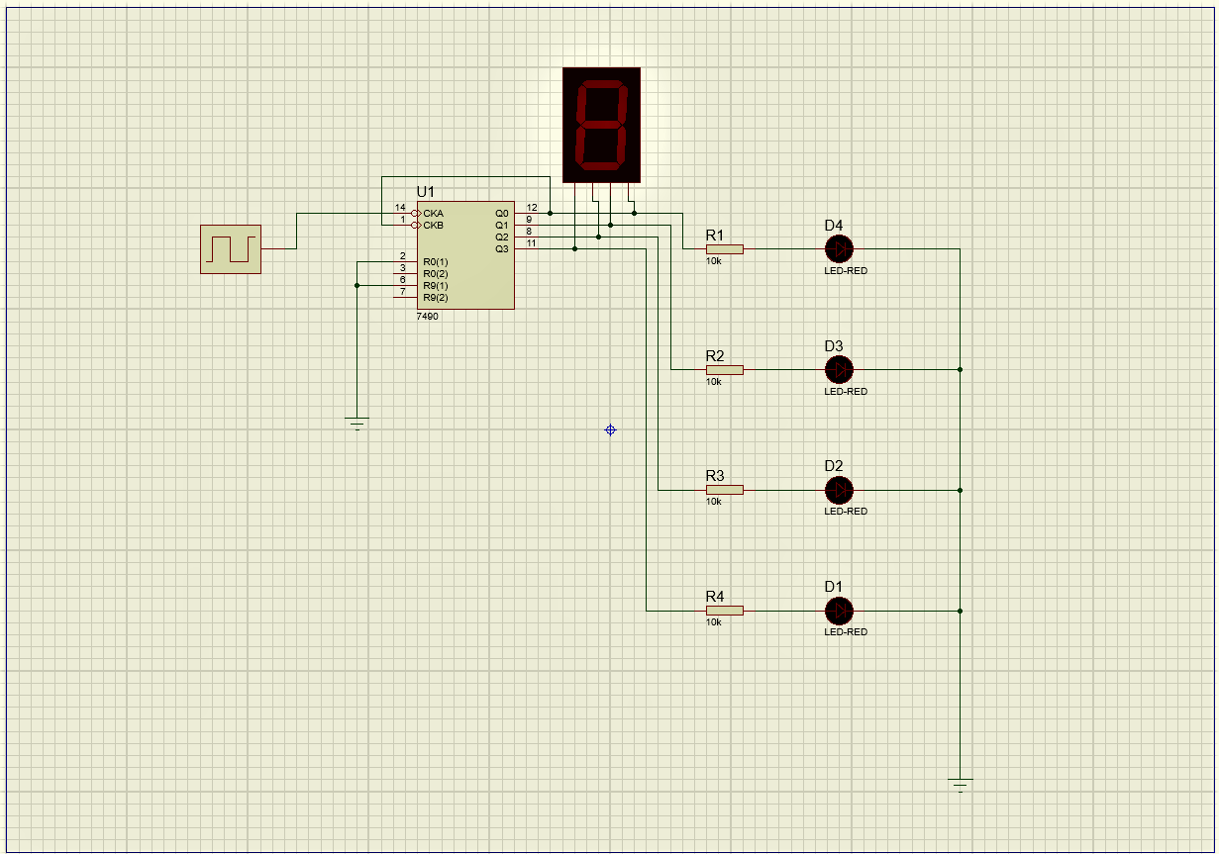

Picture 1.1. Set of clock counter

1. Column table

|  |  |  |  |  |  |
| --- | --- | --- | --- | --- | --- |
| **Input Clock** | **Output LED** | | | | **Output Seven Segment** |
| **D1** | **D2** | **D3** | **D4** |
| **1** | 0 | 0 | 0 | 0 | 0 |
| **2** | 1 | 0 | 0 | 0 | 1 |
| **3** | 0 | 1 | 0 | 0 | 2 |
| **4** | 1 | 1 | 0 | 0 | 3 |
| **5** | 0 | 0 | 1 | 0 | 4 |
| **6** | 1 | 0 | 1 | 0 | 5 |
| **7** | 0 | 1 | 1 | 0 | 6 |
| **8** | 1 | 1 | 1 | 0 | 7 |
| **9** | 0 | 0 | 0 | 1 | 8 |
| **10** | 1 | 0 | 0 | 1 | 9 |

**Experiment 2**

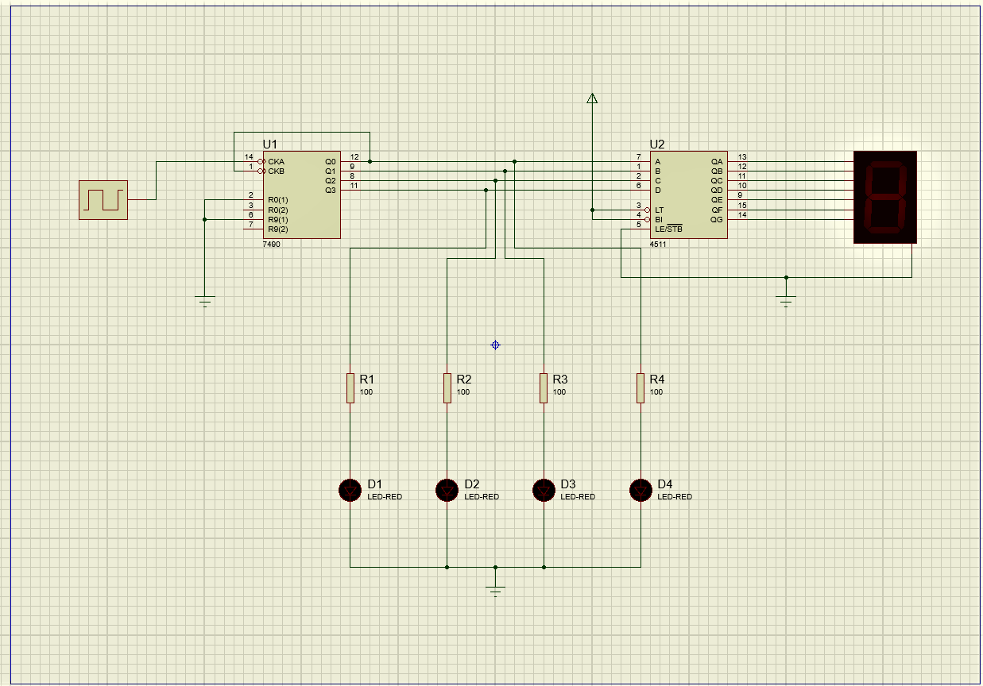

Picture 2.1. Addition of a BCD-to-segment decoder

1. Column table

|  |  |  |  |  |  |
| --- | --- | --- | --- | --- | --- |
| **Input Clock** | **Output LED** | | | | **Output Seven Segment** |
| **D1** | **D2** | **D3** | **D4** |
| **1** | 0 | 0 | 0 | 0 | 0 |
| **2** | 1 | 0 | 0 | 0 | 1 |
| **3** | 0 | 1 | 0 | 0 | 2 |
| **4** | 1 | 1 | 0 | 0 | 3 |
| **5** | 0 | 0 | 1 | 0 | 4 |
| **6** | 1 | 0 | 1 | 0 | 5 |
| **7** | 0 | 1 | 1 | 0 | 6 |
| **8** | 1 | 1 | 1 | 0 | 7 |
| **9** | 0 | 0 | 0 | 1 | 8 |
| **10** | 1 | 0 | 0 | 1 | 9 |

1. Comparison of experiment 1 and experiment 2

In experiment 2, number 6 looks like the letter b and the number 9 looks like the letter q on the 7 segment. but in experiment 1, everything looks normal.

1. Is it true that 7seg-BCD is the same as the BCD-to-7 segment decoder?

Answer : Yes

**Experiment 3**

1. Table function of IC 4511

|  |  |  |  |  |  |  |  |  |  |  |  |  |  |
| --- | --- | --- | --- | --- | --- | --- | --- | --- | --- | --- | --- | --- | --- |
| **Decimal Digit** | **Input** | | | | | **Output** | | | | | | | **Display Output** |
| **LT** | **D** | **C** | **B** | **A** | **a** | **b** | **c** | **d** | **e** | **f** | **g** |
| 0 | H | L | L | L | L | H | H | H | H | H | H | L | 0 |
| 1 | H | L | L | L | H | L | H | H | L | L | L | L | 1 |
| 2 | H | L | L | H | L | H | H | L | H | H | L | H | 2 |
| 3 | H | L | L | H | H | H | H | H | H | L | L | H | 3 |
| 4 | H | L | H | L | L | L | H | H | L | L | H | H | 4 |
| 5 | H | L | H | L | H | H | L | H | H | L | H | H | 5 |
| 6 | H | L | H | H | L | L | L | H | H | H | H | H | 6 |
| 7 | H | L | H | H | H | H | H | H | L | L | L | L | 7 |
| 8 | H | H | L | L | L | H | H | H | H | H | H | H | 8 |
| 9 | H | H | L | L | H | H | H | H | L | L | H | H | 9 |
| LT | L | X | X | X | X | H | H | H | H | H | H | H | 8 |

1. The output "a" (highlight) in the table shows that LED works in seven common cathode segments
2. Each output shows the state of LED from seven segment various conditions
3. Each LED is controlled by a combination of logic gates.

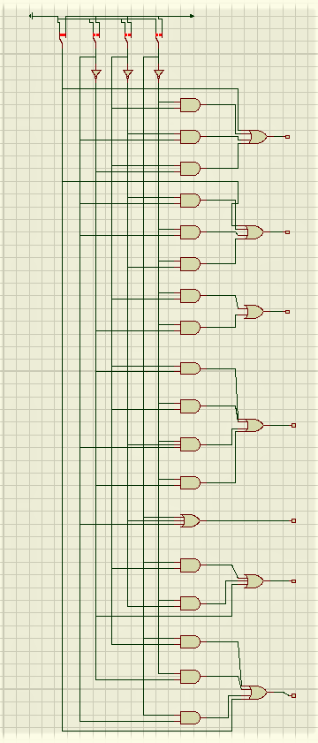

Picture 3.1. Complete diagram logic from BCD-to-7segment decoder

1. Comparison truth table with set of BCD-to-7segment

The output results in the BCD-to-7-segment decoder circuit produce a value that exactly matches the truth table